A000-AM,S-Peru-Moche II-Stirrup spout bottle-Man in a poncho shirt-Red and White Ceramic-100 BCE

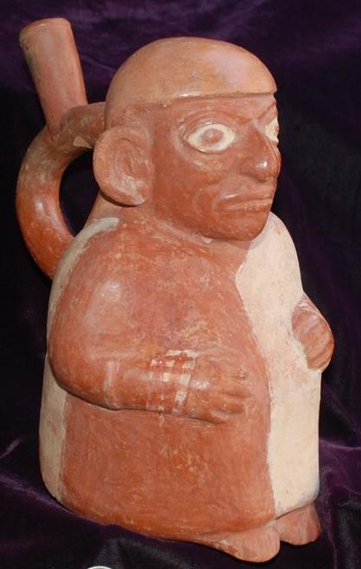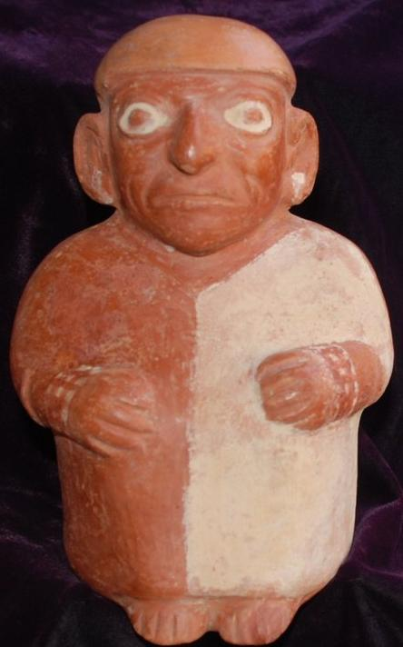

Case No.: 10

**Accession No.**

**Formal Label:**

**Display Description:**

STIRRUP SPOUT BOTTLE IN THE FORM OF A MAN DISPLAYING A PONCHO SHIRT, MOCHE II CULTURE, NORTH COAST OF PERU, ca. 100 CE,

"The formative period of the Moche culture, which lasted from about 400 to 100 B.C., was characterized by the inter-reaction of a number of more or less distinct cultural groups, and the blending of different tradi­tions is manifested in the wide divergence of style found in the art of this period. Finally the warring factions of the Chicama and Moche valleys were united to form a single kingdom. The dominant group appears to have been the Moche Valley people of Cupisnique descent since the new capital of the kingdom was established in the Moche and the prevailing ceramic spout type (Larco's phase III) seems to have evolved from the local Chavinoid style.

During the subsequent flowering of the Moche culture, ceramics were often decorated with scenes of combat and of Moche warriors leading their captives. Some depictions appear to be records of actual military encounters during the wars of unification and the territorial expansion of the Moche kingdom that followed. A few show Moche warriors fighting a group with a distinctive set of costume and armament traits. Their exact identity has not yet been established, and they are referred to here merely as the "ear-drop, star-mace" people. A careful analysis of Moche iconography indicates that these aliens were traders from the interior. They are depicted chewing coca and performing rituals involv­ing that jungle-grown narcotic plant. We see them assembling their trade goods, carrying them over mountains and displaying their wares" (Sawyer 1975: 18-19).

Our example, dating from the beginning of Larco's Moche II phase, depicts a merchant wearing a typical costume, hair style but without the ear-drop that occurs early in Larco's Moche III phase. This special poncho costume is bi-colored cream and red, right and left, and is surmounted with a tight-fitting cap. It functions as a symbolic reminder that this costume identified a particular group of traders from the interior which was absorbed into the Moche kingdom about 200-100 BCE and continued to function primarily as a trader-merchant class until about 800 CE.

**LC Classification:**

**Date or Time Horizon:**

**Geographical Area:**

**Map:**

**GPS coordinates:**

**Cultural Affiliation:**

**Media:**

**Dimensions:** 5 1/2" x 7 1/4" x 8 1/8" ( 14.0 cm x 18.5 cm x 20.7 cm )..

**Weight:**

**Condition:**

**Provenance:**

**Discussion:**

**References:**

Sawyer, Alan R. 1975. Ancient Peruvian ceramics: from the Kehl and Nena Markley collection. University Park: Museum of Art, the Pennsylvania State University.

|  |
| --- |
| Payment details |
|  |
|  |
| Shipping details |
| **Ralph J Coffman Jr**  149 Atlantic Ave  Swampscott MA 01907-2427  United States |

## Order details

|  |  |  |  |
| --- | --- | --- | --- |
| **Item title** | **Available actions** | **Shipping & handling (estimated delivery*)** | **Price** |

[Printer version](http://payments.ebay.com/ws/eBayISAPI.dll?ViewPaymentStatus&transid=0&userloginid=802-867&printerversion=true&itemid=221150589051)

|  |  |  |
| --- | --- | --- |
| Seller: | [**Member id** auau](http://myworld.ebay.com/auau) ( [**Feedback Score Of** 4975](http://feedback.ebay.com/ws/eBayISAPI.dll?ViewFeedback&userid=auau)) | [Contact seller](http://contact.ebay.com/ws/eBayISAPI.dll?ShowCoreAskSellerQuestion&frm=3998&iid=221150589051&redirect=0&requested=auau) |

|  |  |  |  |  |
| --- | --- | --- | --- | --- |
| Paid on Nov-13-12 via PayPal | | | | |
|  |  |  |  |  |

|  |  |  |  |  |  |  |  |
| --- | --- | --- | --- | --- | --- | --- | --- |
| [**Item Title:**SPEAR THROWER WITH SPIRIT IMAGES MIDDLE SEPIK RIVER PAPUA NEW GUINEA **- opens in a new window or tab**](http://cgi.ebay.com/ws/eBayISAPI.dll?ViewItem&item=221150589051)  **Item Id:**221150589051 - Price: US $99.00  Quantity:1  Having a problem with this purchase? [We can help](javascript:;) | |  | | --- | |  | | |  |  | | --- | --- | | [Leave feedback](http://feedback.ebay.com/ws/eBayISAPI.dll?LeaveFeedbackShow&useridfrom=802-867&useridto=auau&item=221150589051&transactid=0) |  | | | Economy Shipping : **US $12.51**  USPS Parcel Post®  Estimated delivery: November 21 - November 29 | US $99.00 |



|  |  |
| --- | --- |
|  |  |

[Printer version](http://payments.ebay.com/ws/eBayISAPI.dll?ViewPaymentStatus&transid=0&userloginid=802-867&printerversion=true&itemid=140881511378)

|  |  |  |
| --- | --- | --- |
| Seller: | [**Member id** verg117](http://myworld.ebay.com/verg117) ( [**Feedback Score Of** 1795](http://feedback.ebay.com/ws/eBayISAPI.dll?ViewFeedback&userid=verg117)) | [Contact seller](http://contact.ebay.com/ws/eBayISAPI.dll?ShowCoreAskSellerQuestion&frm=3998&iid=140881511378&redirect=0&requested=verg117) |

|  |  |  |  |  |
| --- | --- | --- | --- | --- |
| Paid on Nov-13-12 via PayPal | | | | |
|  |  |  |  |  |

|  |  |  |  |  |  |  |  |
| --- | --- | --- | --- | --- | --- | --- | --- |
| [**Item Title:**Pre-Columbian MOCHE II ~ Pre-Colombian Anthropomorphic STIRRUP Spout Vessel ~NR**- opens in a new window or tab**](http://cgi.ebay.com/ws/eBayISAPI.dll?ViewItem&item=140881511378)  **Item Id:**140881511378 - Price: US $450.00  Quantity:1  Having a problem with this purchase? [We can help](javascript:;) | |  | | --- | |  | | |  |  | | --- | --- | | [Leave feedback](http://feedback.ebay.com/ws/eBayISAPI.dll?LeaveFeedbackShow&useridfrom=802-867&useridto=verg117&item=140881511378&transactid=0) |  | | | Expedited Shipping : **US $18.80**  USPS Priority Mail®  Estimated delivery on or before Sat. Nov. 17 | US $450.00 |



**Payment Instructions:**

Hi Ralph, Congratulations !!! and thank you very much for your second purchase. We really appreciate your business. Here's your Total. Shipping, again, is much lower than quoted. Thanks so much. Stephen N Verges. Galleria Verges. 301-922-5838.